Q1.
(a) Give three receptors which a mouse might use to detect food under natural conditions.
1. _________________________________________________________________
___________________________________________________________________
2. _________________________________________________________________
___________________________________________________________________
3. _________________________________________________________________
___________________________________________________________________
(3)
(b) Whilst observing mouse behaviour, a student drops a pen near the mouse’s cage. The mouse jumps at the noise.
Describe, as fully as you can, the processes by which the mouse responds to the stimulus of the dropped pen.
___________________________________________________________________
___________________________________________________________________
___________________________________________________________________
___________________________________________________________________
___________________________________________________________________
___________________________________________________________________
___________________________________________________________________
___________________________________________________________________
___________________________________________________________________
___________________________________________________________________
___________________________________________________________________
___________________________________________________________________
(6)
(Total 9 marks)
Q2.
Coal is used in many power stations.
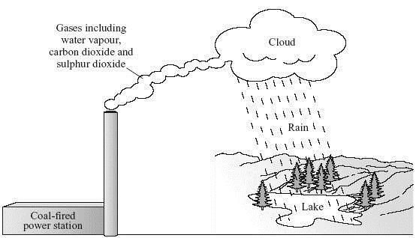
To gain full marks in this question you should write your ideas in good English. Put them into a sensible order and use the correct scientific words.
Use information from the diagram to describe, in as much detail as you can, how using coal in power stations can damage the environment.
_______________________________________________________________________
_______________________________________________________________________
_______________________________________________________________________
_______________________________________________________________________
_______________________________________________________________________
_______________________________________________________________________
_______________________________________________________________________
_______________________________________________________________________
(Total 4 marks)
Q3.
The table gives some information about the African elephant and the woolly mammoth.

African elephant | Woolly mammoth
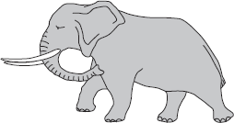 | 
Mass of male: 6000 kg | Mass of male: 8000 kg
Habitat: near the equator | Habitat: northern Europe
An endangered species | Extinct
(a) Use information from the table to help you to answer the following questions.
(i) The diagrams show that both animals have tusks. Tusks help animals to compete.
Suggest two things animals may compete for.
1. ____________________________________________________________
2. ____________________________________________________________
(2)
(ii) The woolly mammoth was adapted to survive during the ice age.
Use information from the table to suggest two ways the woolly mammoth was adapted to survive in the cold.
Adaptation 1: ___________________________________________________
How this helped the woolly mammoth survive: ________________________
______________________________________________________________
______________________________________________________________
Adaptation 2: ___________________________________________________
How this helped the woolly mammoth survive: ________________________
______________________________________________________________
______________________________________________________________
(4)
(b) Darwin’s theory of evolution says that elephants developed a trunk because animals with a longer nose had an advantage over animals with a shorter nose.
The elephants with a longer nose survived to breed and pass on the gene for a longer nose to their offspring.
(i) Name the process by which evolution happens.
______________________________________________________________
(1)
(ii) Describe how Lamarck’s theory would explain how elephants developed a trunk.
______________________________________________________________
______________________________________________________________
______________________________________________________________
______________________________________________________________
(2)
(Total 9 marks)
Q4.
There are areas in deep seas where there are hot water springs called hydrothermal vents.
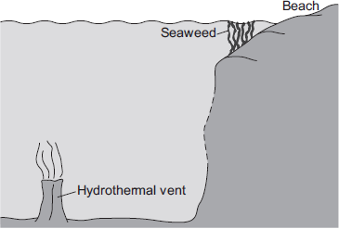
Not to scale
Volcanic activity creates an environment of very hot, acidic water.
No light reaches the deep seabed.
The environment is very extreme but many different organisms can live there.
(a) Complete the following sentence.
Organisms that can survive in extreme conditions are called
___________________________________________________________________
(1)
(b) In the hydrothermal vents bacteria absorb toxic chemicals from the hot water. The bacteria use the chemicals to produce carbohydrates for the rest of the food chain.
The bacteria are eaten by limpets, which are eaten by crabs.
In this question you will be assessed on using good English, organising information clearly and using specialist terms where appropriate.
The food chains show some organisms that live near a hydrothermal vent and some organisms that live near the surface of the sea.
A food chain found near a hydrothermal vent:
bacteria → limpet → crab
A food chain found near the surface of the sea:
green seaweed → limpet → crab
• Give a difference between the food chain found near a hydrothermal vent and the food chain found near the surface of the sea.
• Use information given in this question and your own knowledge to suggest reasons for the difference.
___________________________________________________________________
___________________________________________________________________
___________________________________________________________________
___________________________________________________________________
___________________________________________________________________
___________________________________________________________________
___________________________________________________________________
___________________________________________________________________
___________________________________________________________________
___________________________________________________________________
___________________________________________________________________
___________________________________________________________________
___________________________________________________________________
___________________________________________________________________
___________________________________________________________________
___________________________________________________________________
___________________________________________________________________
(6)
(Total 7 marks)
Q5.
Total cholesterol in the blood contains ‘good’ and ‘bad’ cholesterol.
High levels of ‘bad’ cholesterol increase the risk of heart disease.
High levels of ‘good’ cholesterol reduce the risk of heart disease.
Scientists have suggested that chemicals called polyphenols in dark chocolate may help people with Type 2 diabetes.
Polyphenols may reduce high levels of ‘bad’ cholesterol in the blood.
The scientists investigated the effect of polyphenols on levels of cholesterol in the blood.
• 7 men and 5 women with Type 2 diabetes had the levels of cholesterol in their blood measured.
• They all ate 45 g of dark chocolate every day for 16 weeks.
• 6 of the people ate dark chocolate that contained polyphenols. The other 6 people ate dark chocolate that did not contain polyphenols.
• All 12 people were allowed to eat and drink anything else they wanted, but no more chocolate.
• The levels of cholesterol in their blood were measured again after 16 weeks.
The results showed that for the people who ate dark chocolate with polyphenols:
• there were decreases in total cholesterol and ‘bad’ cholesterol
• there was an increase in ‘good’ cholesterol.
A newspaper headline reported the research and wrote:
‘Research shows that diabetics should eat dark chocolate.’
In this question you will be assessed on using good English, organising information clearly and using specialist terms where appropriate.
Was the newspaper’s statement justified?
Include in your answer evidence that supports the newspaper’s statement and evidence that does not support the newspaper’s statement.
Remember to give a conclusion to your answer.
_______________________________________________________________________
_______________________________________________________________________
_______________________________________________________________________
_______________________________________________________________________
_______________________________________________________________________
_______________________________________________________________________
_______________________________________________________________________
_______________________________________________________________________
_______________________________________________________________________
_______________________________________________________________________
_______________________________________________________________________
_______________________________________________________________________
_______________________________________________________________________
_______________________________________________________________________
(Total 6 marks)
Q6.
In this question you will be assessed on using good English, organising information clearly and using specialist terms where appropriate.
The drawing shows the shapes of trees growing on their own and inside a forest.
The trees are of the same species.
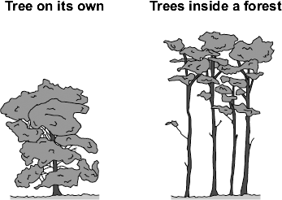
Describe the differences between the tree growing on its own and the trees inside the forest.
Suggest reasons for the differences you have described.
_______________________________________________________________________
_______________________________________________________________________
_______________________________________________________________________
_______________________________________________________________________
_______________________________________________________________________
_______________________________________________________________________
_______________________________________________________________________
_______________________________________________________________________
_______________________________________________________________________
_______________________________________________________________________
_______________________________________________________________________
_______________________________________________________________________
_______________________________________________________________________
(Total 6 marks)
Q7.
Many diseases are caused by viruses. Children are given vaccines to protect them against viral disease.
(a) Explain how vaccination protects a child against a viral disease.
___________________________________________________________________
___________________________________________________________________
___________________________________________________________________
___________________________________________________________________
___________________________________________________________________
___________________________________________________________________
(3)
(b) In the 1990s many people thought that the MMR vaccine caused autism in some children. This is why the Japanese government stopped using the MMR vaccine.
The graph gives information about the percentage of Japanese children who developed autism during the 1990s.
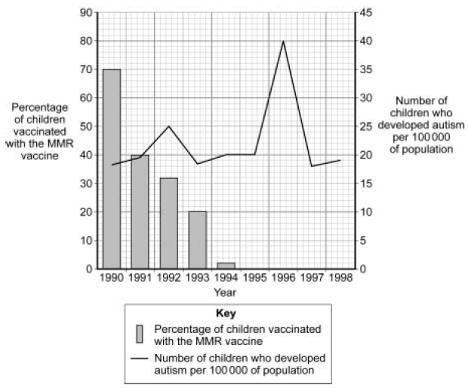
The data in the graph support the view that there is no link between MMR vaccination and autism.
Explain why.
___________________________________________________________________
___________________________________________________________________
___________________________________________________________________
___________________________________________________________________
___________________________________________________________________
___________________________________________________________________
___________________________________________________________________
___________________________________________________________________
___________________________________________________________________
(4)
(Total 7 marks)
Q8.
In this question you will be assessed on using good English, organising information clearly and using specialist terms where appropriate.
There are millions of plastic bags in use. After use most of these plastic bags are buried in landfill sites. The amount sent to landfill could be reduced if the plastic bags:
• could be reused
• could be recycled by melting and making them into new plastic products
• could be burned to release energy.
Use the information above and your knowledge and understanding to give the positive and negative environmental impacts of using these methods to reduce the amount of plastic bags sent to landfill.
_______________________________________________________________________
_______________________________________________________________________
_______________________________________________________________________
_______________________________________________________________________
_______________________________________________________________________
_______________________________________________________________________
_______________________________________________________________________
_______________________________________________________________________
_______________________________________________________________________
_______________________________________________________________________
_______________________________________________________________________
_______________________________________________________________________
_______________________________________________________________________
_______________________________________________________________________
_______________________________________________________________________
(Total 6 marks)
Mark schemes
Q1.
(a) light/eye
smell/nose
taste/chemical/tongue
for 1 mark each
3
(b) 6 of e.g.
receptors in ear detect sound waves/vibrations
impulses/electrical signals to brain
brain co-ordinates response
impulses sent along nerves
to muscles/effectors which contract to bring about response
any 6 for 1 mark each
6
[9]
Q2.
Quality of Written Communication
1 mark for correct sequencing
burning → named gas → correct
environmental problem
1
any three from:
coal / fossil fuel is burned
(water vapour and carbon dioxide and) sulphur dioxide formed
accept nitrogen oxides
(gases) dissolve / react in rain
accept dissolve / react in water vapour
make acid rain
damages trees
accept harms plants or animals or damage to buildings
makes rivers /lakes acidic
accept carbon dioxide is a greenhouse gas / causes global warming for 2 marks
3
[4]
Q3.
(a) (i) any two from:
• food
• mates
• territory / space
ignore habitat, land
ignore water
2
(ii) any two adaptations with explanations from:
1 mark for adaptation
1 mark for correct explanation
ignore prevents / no heat loss
• long / thick hair or wool
allow a lot of
allow long / thick / a lot of fur
ignore fat although reason can still be credited
ignore coat
(for) insulation
allow (to) trap energy / heat / air
allow to keep warm
• small surface area : volume ratio
ignore large body mass although reason can still be credited
(therefore) lose less energy
allow (to) keep warm
allow heat for energy
ignore (to) insulate
• small ears / tail
allow (to) keep warm
allow heat for energy
(therefore) lose less energy
ignore (to) insulate
only allow big tusks if qualified eg digging through snow / ice for(food) for 2 marks
ignore references to predators and prey
only allow big feet if qualified eg for walking on snow / ice for 2 marks
4
(b) (i) natural selection
1
(ii) if some animals grew a long nose / acquired characteristic (during their lifetime)
ignore answers about Darwin's theory
allow trunk for nose
allow used trunk / nose / it a lot
allow stretched trunk / nose / it
1
their offspring would inherit / also have a long nose
do not accept references to genes / DNA / chromosomes
1
[9]
Q4.
(a) extremophiles
accept named examples eg acidophiles, thermophiles, thermophytes, halophytes
1
(b) Marks awarded for this answer will be determined by the Quality of Written Communication (QWC) as well as the standard of the scientific response. Examiners should apply a ‘ best-fit’ approach to the marking.
0 marks
No relevant content
Level 1 (1 – 2 marks)
Either a difference or a reason is given.
Level 2 (3 – 4 marks)
A difference is given and an attempt to suggest reason(s) for the difference.
Level 3 (5 – 6 marks)
A difference is given and suitable reasons, which add value, to explain the difference.
Difference
• food chain near hydrothermal vent begins with bacteria
• food chain near surface of the sea begins with seaweed
allow no seaweed at the bottom of the sea
• use different energy sources
• producers (in the two chains) are different
allow limpets eat different foods
accept bacteria / limpets / crabs (in the 2 areas) are different (species)
or
have different adaptations
or
have evolved differently
examples of scientific points made in the response
• seaweed is an alga
allow plant
• seaweed absorbs light / energy from sun
• for photosynthesis
• to make glucose / sugar/ carbohydrate / food
allow chemical energy
• no light at bottom of sea
allow no sun (light)
• plants can’t survive in the dark / conditions at the bottom of sea
allow descriptions of conditions e.g. harsh
• bacteria are extremophiles
allow thermal energy or ‘heat’
• bacteria need different energy source / use chemical energy
• to make carbohydrate / food
6
[7]
Q5.
Marks awarded for this answer will be determined by the Quality of Written Communication (QWC) as well as the standard of the scientific response.
Examiners should also refer to the information on the marking guidance (see Reference Material), and apply a 'best-fit' approach to the marking.
0 marks
No relevant content.
Level 1 (1-2 marks)
There is a brief description of the evidence for or against the newspaper’s claim, including either evidence for or evidence against.
Level 2 (3-4 marks)
There is a description of some of the evidence for and evidence against the newspaper’s claim, with at least one example of evidence for and one example of evidence against. There is an attempt at a conclusion.
Level 3 (5-6 marks)
There is a clear and detailed description of the evidence for and evidence against the newspaper’s claim, with at least one example for and at least two examples against. A reasoned conclusion is given. The description must include reference to polyphenols.
Examples of the chemistry points made in the response
Evidence supporting the newspaper claim:
• the study included a control group / one group given a placebo
• all participants ate the same amount of chocolate each day
• results showed a decrease in total cholesterol / an increase in ‘good’ cholesterol / a decrease in ‘bad’ cholesterol in the group that ate the dark chocolate
allow (dark) chocolate worked / reduced (risk of) heart disease
Evidence against the newspaper claim:
• no results given for (dark) chocolate without polyphenols
• only type 2 diabetes patients tested
• small sample tested / only 12 tested
• unequal numbers of males and females
• other health issues / age not controlled
• rest of diet not controlled
• chocolate contains high levels of fat / sugar / could cause other health issues eg weight gain
• long term effects not known / trial only 16 weeks
Argued conclusion made with an attempted justification
[6]
Q6.
Marks awarded for this answer will be determined by the Quality of Written Communication (QWC) as well as the standard of the scientific response. Examiners should also refer to the information on the marking guidance (see Reference Material), and apply a ‘best-fit’ approach to the marking.
0 marks
No relevant information.
Level 1 (1-2 marks)
There is a basic description of either differences or explanations only.
Level 2 (3-4 marks)
There is a clear description of at least one difference with a correctly linked attempt at an explanation.
Level 3 (5-6 marks)
There is a clear and detailed description of at least two differences explained and correctly linked. Competition explained
Examples of the points made in the response
allow converse statements for trees in forest
description of tree on its own.
• is wider / bushier
allow (leaves / branches) spread out
• has more leaves
• is shorter
ignore trunks
• has leaves all over tree
ignore size of leaves
explanation linked:
• more space
• more light
• more nutrients
allow photosynthesise more
ignore reference to being eaten
is shorter cannot be linked with more nutrients
ignore tree roots unless clearly linked to obtaining nutrients
competition mentioned:
• for light
ignore fight
• for nutrients
ignore water and carbon dioxide
• for space
ignore evolution / natural selection / adapting
[6]
Q7.
(a) dead / inactive form of virus introduced into body
1
white blood cells stimulated to produce antibodies
1
correct antibodies rapidly made if the body is infected with the virus
1
(b) the percentage of children vaccinated fell to zero in 1995
1
but the number of children developing autism rose and fell
during the period when % vaccinations was falling
1
number of children developing autism peaked after MMR
vaccination had ceased
1
which suggests that something other than MMR vaccination
was causing autism
1
[7]
Q8.
Marks awarded for this answer will be determined by the Quality
of Written Communication (QWC) as well as the standard of the
scientific response.
No relevant content.
0 marks
There is a brief description of a positive and a negative environmental
impact involved with one or more methods used to reduce the
amount of plastic bags sent to landfill.
Level 1 (1–2 marks)
There is some description of both positive and negative
environmental impacts involved with at least 2 methods used
to reduce the amount of plastic bags sent to landfill.
Level 2 (3–4 marks)
There is a clear, balanced and detailed description of both a
positive and a negative environmental impact of using each
of the 3 methods used to reduce the amount of plastic bags
sent to landfill.
Level 3 (5–6 marks)
examples of the points made in the response
Reuse:
Reuse means less bags used so:
Positive environmental impact
• Saves raw materials/crude oil
• Saves energy
• Cuts down on CO₂ emissions
• Less global warming
Negative environmental impact
• Could cause litter
• Could still be sent to landfill
Recycle:
Bags can be recycled so:
Positive environmental impact
• Used to make new plastic bags / objects
• Saves raw materials / crude oil
• Saves energy compared to producing plastic bags from crude oil
• Cuts down on CO₂ emissions
• Less global warming
Negative environmental impact
• Collection point sites cause an eyesore / litter problem
• Transportation to recycling plant releases carbon dioxide / causes global warming
Burn:
Bags can be burned so:
Positive environmental impact
• Could provide energy for heating buildings
• Could provide energy for generating electricity
Negative environmental impact
• Increases CO₂ emissions
• Increases global warming
• Could release toxic gases
• Does not conserve raw materials / crude oil
[6]

